| **CRONOGRAMA (SEMANA FINAL)** | | | | | | | | | | **Fecha: 15-Agosto-2024** | |
| --- | --- | --- | --- | --- | --- | --- | --- | --- | --- | --- | --- |
| **Revisión: 1.0** | |
|  | | | | | | | | | | | |

ELABORÓ AUTORIZÓ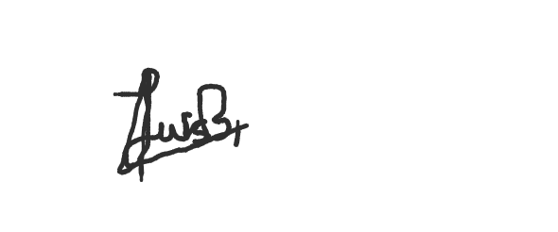

LUIS EDUARDO BAHENA CASTILLO BRENDA JOHANA GÁLVEZ ÁLVAREZ